**Options on how to setup the database:**

**Option 1:** Restored the backup (.bak) file in your SQL server *(the bak file is located at* ***InitialDB*** *folder; please see screenshot below for your reference)*.

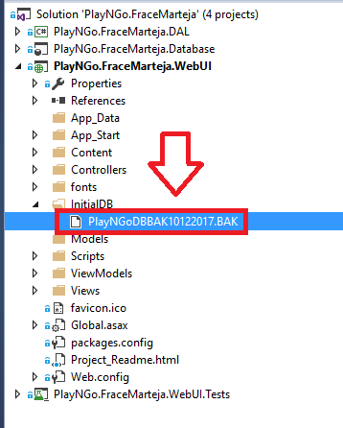

**Option 2:** Double click the “***PlayNGo.FraceMarteja.Database.publish.xml***” file in database project so that Visual Studio will do the database creation and tables creation for you after you click the publish button. Please see screenshot below for your reference.

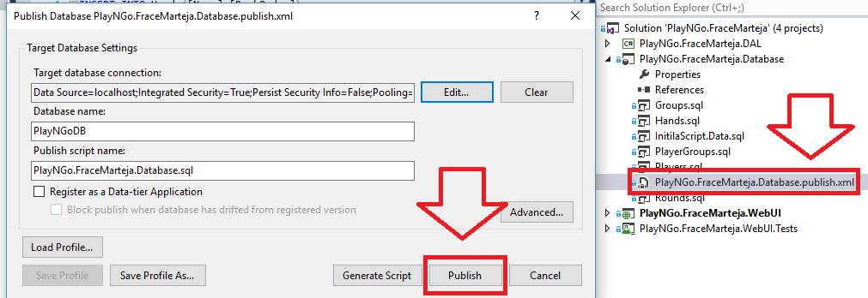

How to use the Program:

1. Add Player by clicking “Add New” button, then input name and gender, then click “Save” button to save it into the database and will be available in the players selection.

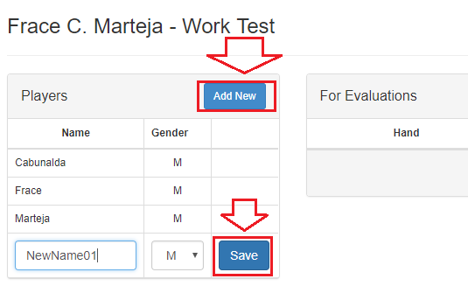

1. Click “Add New” button to add new row which contains *(Hand selection, Player(s) multiple selection)*. Select a “Hand” from the dropdown, the select at least one player name, then click save.

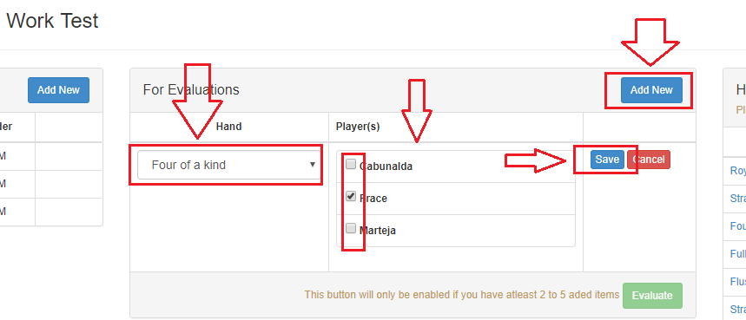

1. Click “Evaluate” button to determine which hand is the winner.

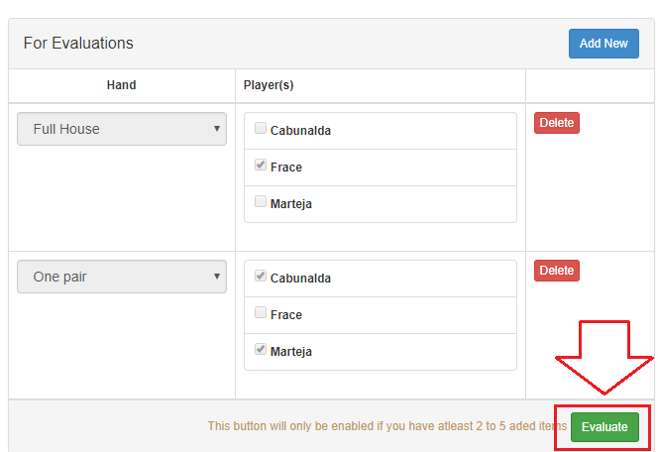

1. To try another evaluation, just click the “New Evaluation” button.

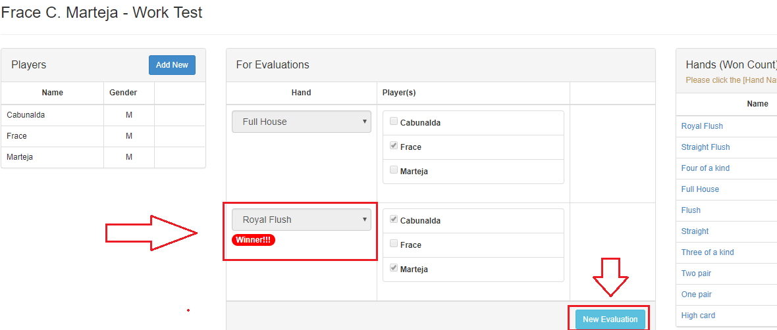

1. To View the history, just click the “Hand” name and a dialog will pop-up containing the history of the selected hand.

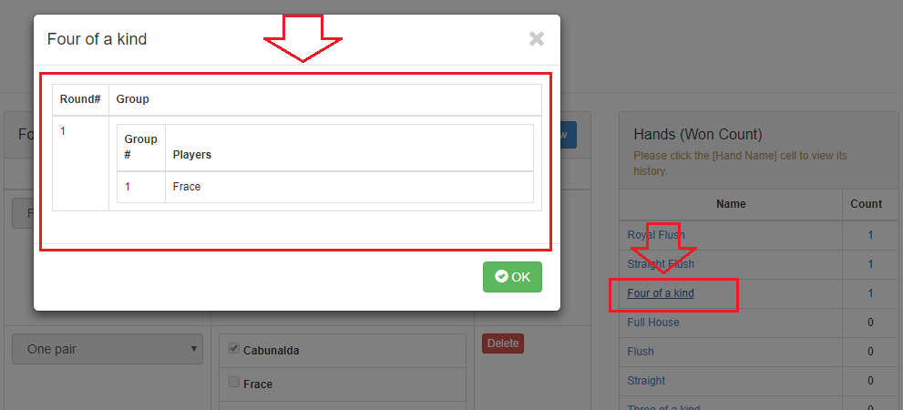

That’s all.. Thanks.. ☺